SIMATS ENGINEERING

ASSESSMENT TOOL 1

COURSE NAME: COMPUTER NETWORKS COURSE CODE: CSA07

COURSE OUTCOME COVERED

CO5:
Design network topologies star, mesh, bus, and hybrid using networking devices, transmission media, and cabling standards (BL2,BL5)

Assessment Tool Weightage: 40%

QUESTIONS: 3 Total Marks:30

Annexure A

Constraint-Based Problem Solving

Code of Conduct:
I Ashwin V–(192424345) (Name / Reg No) certify that this submission is my original work and that I have adhered to the guidelines specified for this assessment.
I understand that any violation of academic integrity rules will result in disciplinary action.
Signature of the student: Ashwin V–(192424345)
Annexure A

Constraint-Based Problem Solving
- A multinational company is opening a new branch office in a remote rural location where high-speed wired internet is unavailable. The office must support cloud-based applications, video conferencing, and secure communication with the headquarters. The company has a limited budget for connectivity but requires uninterrupted business operations. As a network engineer, recommend a suitable internet connection, networking devices, and security mechanisms. Justify your recommendations by considering bandwidth limitations, reliability, cost, and future scalability
- A university plans to provide campus-wide wireless internet access for more than 3,000 students across classrooms, laboratories, libraries, and hostels. The network must support a large number of simultaneous users while minimizing signal interference and ensuring secure access. Due to budget constraints, only a limited number of wireless access points can be deployed. Analyze the requirements and propose an efficient wireless network design, including access point placement, frequency band selection, and authentication methods. Explain how your solution balances coverage, performance, security, and cost.
- A financial institution is upgrading its internal computer network to improve cybersecurity while allowing employees to access sensitive customer information and online banking services. The organization must comply with strict security policies without significantly affecting network performance or increasing operational costs. Design a secure network architecture by selecting appropriate network segmentation techniques, firewall deployment, authentication methods, and intrusion detection mechanisms. Justify your design by considering the constraints of security, performance, compliance, and budget.
RUBRICS FOR CALCULATION

Criteria | Weightage (%) | Exemplary (4) | Proficient (3) | Developing (2) | Beginning (1)

Understanding of Problem & Constraints | 20% | Clearly  identifies all  constraints and fully  understands the problem  requirements | Identifies most constraints with minor  gaps in understanding | Identifies some constraints but misses key  aspects | Shows little or no understanding of constraints or problem
Problem Decomposition | 15% | Breaks problem into logical, wellstructured subproblems effectively | Breaks problem into sub-parts with some logical  flow | Attempts decomposition but lacks clarity or  structure | No clear decomposition  of the problem
Application of Constraints in Solution | 20% | Applies all constraints  correctly and  consistently in solution design | Applies most constraints correctly with minor errors | Applies some constraints but with noticeable errors | Fails to apply constraints appropriately
Logical Reasoning & Strategy | 15% | Uses strong, clear, and efficient reasoning  strategies | Uses generally sound reasoning with minor gaps | Reasoning is partially correct but inconsistent | Reasoning is unclear or incorrect
Solution Accuracy & Feasibility | 15% | Solution is fully correct, feasible, and optimized | Solution is mostly correct and feasible | Solution has errors or is partially  feasible | Solution is incorrect or not feasible
Creativity & Innovation | 5% | Demonstrates highly  innovative and  unique approach | Shows some creativity in approach | Limited creativity shown | No creativity; relies on basic or copied ideas
Clarity of  Presentation | 10% | Solution is clearly presented with excellent organization and explanation | Presentation is clear with minor issues | Presentation  lacks clarity or organization | Poorly presented and difficult to understand

Annexure A – Constraint-Based Problem Solving
- Internet Connectivity for a Remote Rural Branch Office
A suitable solution is a hybrid satellite/4G/5G connectivity system, depending on availability at the rural location. Satellite internet can serve as the primary connection where terrestrial broadband is unavailable, while 4G/5G can act as a backup connection.

Recommended network design:
  - Internet connection: Business-grade satellite broadband as the primary link, with 4G/5G as a secondary link.
  - Router: Enterprise router supporting dual-WAN, automatic failover, QoS, and VPN.
  - Switch: Managed Gigabit Ethernet switch for connecting computers, servers, printers, and access points.
  - Wireless access points: Business-grade Wi-Fi 6 access points for office users.
  - Security: Next-generation firewall, site-to-site VPN, WPA3/WPA2-Enterprise, antivirus/endpoint protection, and regular security updates.
  - Power reliability: UPS units for the router, satellite equipment, switches, and critical computers.

Justification:
Satellite internet provides connectivity where wired infrastructure is unavailable, although latency can be higher and bandwidth may be more expensive. QoS can prioritize video conferencing, cloud applications, and business-critical traffic. A secondary 4G/5G connection provides redundancy, reducing downtime if the primary link fails. The VPN creates an encrypted connection between the branch and headquarters. A

dual-WAN router enables automatic failover without requiring manual intervention.
The design is also scalable because additional users, access points, and network devices can be added later. Although the initial cost is higher than using a single consumer connection, redundancy and centralized security help maintain uninterrupted business operations.
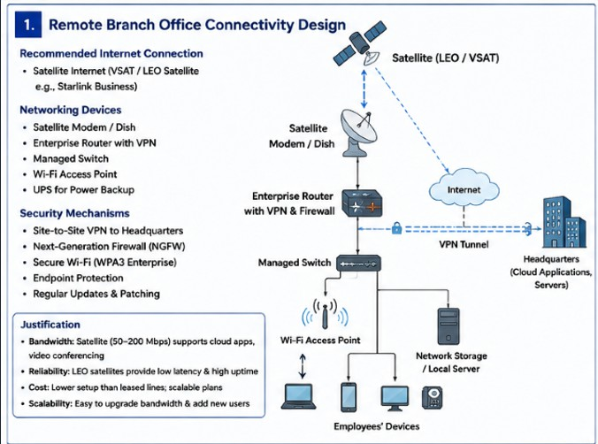

Campus-Wide Wireless Network for More Than 3,000 Students
For a university with more than 3,000 users, the network should use a centrally managed Wi-Fi 6/6E infrastructure with carefully planned access-point placement rather than simply maximizing coverage.

Recommended wireless design:
  - Conduct a wireless site survey before installing access points.
  - Deploy access points in classrooms, laboratories, libraries, hostels, and other high-density areas according to expected user density.
  - Use ceiling-mounted APs where possible and avoid placing them near large metal objects, electrical equipment, or sources of interference.
  - Prefer 5 GHz and 6 GHz bands for high-capacity users, while retaining
2.4 GHz for devices that require greater range or compatibility.
  - Use non-overlapping channels and automatic radio-frequency management to reduce interference.
  - Reduce unnecessary transmit power so that neighboring APs do not excessively overlap.
  - Use a wireless controller or cloud-based management system for centralized configuration and monitoring.

Authentication and security:
  - Use WPA3-Enterprise where supported.
  - Authenticate students and staff through 802.1X with a RADIUS server.
  - Create separate SSIDs/VLANs for students, staff, guests, and administrative devices.

  - Apply bandwidth limits or QoS policies to prevent a small number of users from consuming excessive bandwidth.

Justification:
Because the number of APs is limited, they should be placed according to user density rather than geographical coverage alone. High-density areas such as lecture halls and libraries require greater capacity, whereas corridors require less capacity. Using 5 GHz/6 GHz reduces congestion compared with relying heavily on 2.4 GHz.
Centralized management makes it possible to monitor interference, user load, and AP performance. VLAN separation and enterprise authentication protect university resources while allowing legitimate users to access the network. This approach balances coverage, capacity, security, and cost by using fewer but strategically positioned, high-capacity APs.

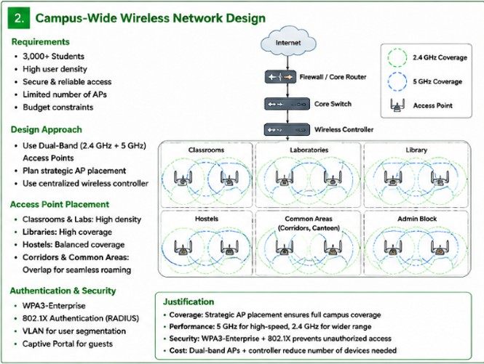

Secure Network Architecture for a Financial Institution
The financial institution should adopt a segmented, defense-in-depth architecture so that sensitive customer information is isolated from ordinary employee and internet traffic.

Recommended architecture:
Internet → Edge Router → Next-Generation Firewall → DMZ / Internal Firewall → Segmented Internal Networks
The internal network can be divided into separate VLANs/security zones such as:
  - Employee VLAN: Normal employee computers and office applications.

  - Customer-data VLAN: Systems containing sensitive customer information.
  - Application/server VLAN: Banking applications and internal servers.
  - Management VLAN: Network and security administration systems.
  - Guest VLAN: Internet-only access for visitors.
  - DMZ: Public-facing services that must be accessible from the internet.

Security mechanisms:
  - Deploy a next-generation firewall at the internet edge with application control, access-control policies, and VPN support.
  - Use additional internal firewall controls between high-risk or highly sensitive zones.
  - Implement 802.1X authentication for network access.
  - Use multi-factor authentication (MFA) for administrators and access to sensitive applications.
  - Apply role-based access control (RBAC) so employees can access only the information required for their jobs.
  - Deploy IDS/IPS to detect and block suspicious network activity.
  - Encrypt sensitive information both in transit and at rest.
  - Maintain centralized logging and security monitoring through a SIEM where practical.
  - Regularly patch systems and perform vulnerability assessments.

Justification:
Segmentation limits the damage caused by a compromised device because

attackers cannot freely move between network zones. Sensitive customer databases can therefore be isolated from employee and guest networks. Firewalls enforce communication rules between these zones, while IDS/IPS provides additional protection against attacks.
802.1X and MFA strengthen authentication without requiring major changes to normal employee workflows. Centralized monitoring improves compliance and incident response. To control operational costs, the organization can use existing managed switches where possible, virtual firewall functions, centralized security management, and automated monitoring rather than deploying separate expensive appliances for every department.
